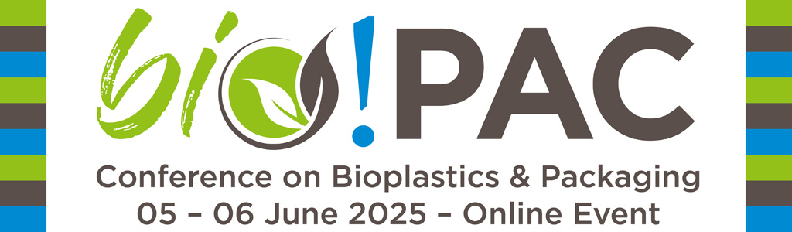

**Press Release**

**Cut the Carbon with Bioplastics Packaging**

**International online conference bio!PAC on bioplastics & packaging**

Most plastic packaging is made from fossil-based resources, is rarely recycled, and not biodegradable. Additionally, plastic packaging can contribute to the long-term accumulation of microplastics. Innovative bioplastics can offer a sustainable alternative. They bring new functionalities and can have multiple end-of-life options: recyclable and/or biodegradable. Furthermore, some bioplastics can be produced and recycled with a lower energy and carbon footprint.

**Bioplastics Packaging**

* can be recyclable, biodegradable, or both
* derived from renewable carbon sources: biomass, CO2, or recyclate
* can offer innovative features and beneficial improved barrier properties
* can help to prevent the accumulation of microplastics in our environment
* contributes to reduce depletion of finite fossil resources and lowers CO2 emissions

**Online conference bio!PAC**

That’s why Renewable Carbon Plastics Magazine, in cooperation with Green Serendipity, is organizing the 6th edition of [bio!PAC](https://www.bioplasticsmagazine.com/en/event-calendar/termine/bio-pac-2025/) - the international conference on bioplastics & packaging.

Experts from all areas of bioplastics & packaging will present their latest developments and scientific research. The conference will cover topics such as packaging material innovations, end-of-life options, certifications, policies, land use, and the issue of microplastics.

**Confirmed speakers**

Confirmed speakers from, among others, Mars, FrieslandCampina, Lamb Weston, Emirates Biotech, Kaneka, and the European Commission.

This online event will be recorded and made available for convenient viewing (video on demand) for at least a month after the event. All presentations will also be available as PDFs.

More information: [**bio-pac.info**](https://t9b8374d4.emailsys1a.net/c/31/8285778/2263/0/51175544/5899/652316/237afbfbc9.html)

**Press Contact:**

***Polymedia Publisher GmbH***  
Dr. Michael Thielen  
Hackesstr. 99  
41066 Mönchengladbach, Germany  
Tel.: +49 2161 664864  
[mt@bioplasticsmagazine.com](mailto:mt@bioplasticsmagazine.com)  
[www.bioplasticsmagazine.com](https://t9b8374d4.emailsys1a.net/c/31/8285778/2263/0/51175544/5899/652279/28452093f1.html)

***Green Serendipity | Bioplastics Hub***

Caroli Buitenhuis

Amsterdam, The Netherlands  
[Info@greenserendipity.nl](mailto:Info@greenserendipity.nl)

[www.greenserendipity.nl](http://www.greenserendipity.nl) / [www.bioplasticshub.com](http://www.bioplasticshub.com)

